Foundation for Polish Science (FNP)

with its registered office in Warsaw 02-611, ul. I.

Krasickiego 20/22

European Funds for a Smart Economy Programme (FENG)

Application for project funding

in the call for

1/2026

FIRST TEAM

Priority axis Measure

Environment enhancing innovation

First Team

FENG.02.02-IP.05-0001/26
Application for Funding number | Date of application | Call number
Application for Funding number | submission | Call number

1 | P a g e

GENERAL INFORMATION

Applications must be submitted electronically using the FNP electronic system by registering at https://wnioski2023.fnp.org.pl. After logging into the electronic system, select the appropriate call for proposals for Measure 2.2 FENG First Team from the list of available calls, and then proceed to fill in the Application for Funding. The electronic form should be completed in Polish or in English, as specified in the Application. Annexes should be uploaded to the system using the appropriate form templates. The templates can be found both in the "Downloads" section and in each section requiring the attachment of the relevant document.

1. Project Information

Basic Project Information

Project Number

Project Title

Brief Project Description (abstract)

Keywords

Field and specialisation (according to OECD (more than one may be indicated))

The National Smart Specializations (NSS) area to which the Project belongs

Justification of the selected NSS area Project commencement date

Project completion date

Project implementation location

Building Number


Apartment Number

(generated by the system)


Max. 300 characters

Max. 2000 characters

Max. 300 characters


Field of science – Level 1

Drop-down list

Discipline – level 2

Drop-down list

Specialisation – level 3

Drop-down list

Drop-down list

Max. 1000 characters

yyyy.mm.dd

To be entered by the Applicant
yyyy.mm.dd

To be entered by the Applicant Voivodeship (select from drop-down) District (select from drop-down) Municipality (select from drop-down) Town/City (select from drop-down) Street (select from drop-down)


…

…

Page 2 from 18

- APPLICANT (INSTITUTION) AND PRINCIPAL INVESTIGATOR OF THE PROJECT

1/3 Applicant

Name

Tax Identification Number (NIP)

Legal form

Form of ownership

Country

Postal Code

Applicant’s address

Building number

Apartment number

E-mail

Telephone number

Website

…

…

Drop-down list

Drop-down list

Drop-down list (in accordance with call regulations – Poland)

…


Voivodeship (select from drop-down)

District (select from drop-down)

Municipality (select from drop-down)

Town/City (select from drop-down)

Street (select from drop-down)

…

…

…

…

…

Correspondence Address (if different from above) (dropdown list)

Postal Code

Correspondence address

Building number

Apartment number

E-mail

Telephone number


Unit within the research organisation (Applicant) where the Project will be carried out

…


Voivodeship (select from drop-down)

District (select from drop-down)

Municipality (select from drop-down)

Town/City (select from drop-down)

Street (select from drop-down)

…

…

…

…


…

Page 3 from 18

2/3 Contact person for the Project evaluation on behalf of the Applicant (must be a person other than the Principal Investigator)

First Name …

Surname …

Academic title/degree …

E-mail …

Telephone number …

3/3 Principal Investigator of the Project

First Name

Surname

Academic title/degree

Nationality

Polish citizenship

Country of residence

Town/City

Postal code

Street

Building number

Apartment number

Correspondence E‑mail

Telephone number

Website

Current place of employment (institution and unit)

Date of obtaining the doctoral degree Document confirming the award of a doctoral degree

Extension of the period from the defence of the doctoral thesis beyond 9 years (The 9-year period may be extended by: 1) all documented periods of interruption in academic work, including unpaid leave, parental leave, interruptions due to long-term illness, work in the R&D sector without participation in scientific research, work in other sectors of the economy, etc., 2) the birth or adoption of a child, confirmed by a document (the 9-year period is extended by 1 year for each child), taking into account breaks lasting at least 6 months)

…

…

…

Drop-down list

Yes/No (select one)

…

…

…

…

…

…

…

…

…

…

YYYY/MM/DD

Attachment confirming the award of a doctoral degree in PDF format (maximum 1 attachment)


Yes/No (select one)

Attachments confirming breaks in scientific work (pdf)

Page 4 from 18

The most important scientific achievements of the Principal Investigator and their contribution to the development of the given scientific field (publications, patent applications, patents, prototypes, etc.) (1 achievement = 1 attachment)


Type of scientific achievement

Achievement 1

Drop-down list:

Publication

Patent application Patent
Prototype Other

Title of scientific achievement/ Contribution of the Principal

Attachment with the scientific Investigator Scientific

achievement achievement to the given field

development


Text field for entering the tile of

achievement (max 200 characters)

max. 500 characters

Place to upload an attachment (max. 1

attachment in pdf format)

+ possibility to add another achievement (limit up to 5 achievements)

Experience of the Project’s Principal Investigator gained during the scientific career

Research internship duration – start date

Research internship duration – end date

Location

Description of gained experience


Description of result(s) of the internship (e.g. publications, patent applications, patents, collaborations, etc.)

YYYY/MM/DD

YYYY/MM/DD

Max. 100 characters

Max. 500 characters


Max. 500 characters

+ possibility to add another internship (no limit)

Principal Investigator’s experience in implementation of research projects or in supervision of students or doctoral students

Principal Investigator’s experience in implementation of research projects

Project name/title | Max. 200 characters
Role of the Principal | Max. 500 characters
Investigator in the project | Max. 500 characters
 | Page 5 from 18

Project implementation
period | YYYY/MM/DD-YYYY/MM/DD
Source of project funding | Max. 500 characters
Description of gained | Max. 1000 characters
experience | Max. 1000 characters
Description of results (e.g. | Max. 1000 characters
publications, patent | Max. 1000 characters
applications, patents,
collaborations, etc.)


+ Possibility to add another project (no limit)

Principal Investigator’s experience in | Max. 2000 characters
supervision of students or doctoral students | Max. 2000 characters


Personal or capital ties with companies
operating in the area of the Project's scientific ^{Max. 2000 characters} activity (if applicable)

How the Applicant manages conflicts of
interest in the event of personal or capital links ^{Max. 2000 characters} with enterprises (if applicable)


Planned employment of the Project’s Principal
Investigator during Project implementation ^{0,5-1,0} (not less than 0,50 of full-time equivalent)

3. PARTNERS

1/2 Foreign Research Partner

First name

…

Surname

…

Academic title/degree

…

Correspondence E-mail

…

Telephone number

…

Page 6 from 18

Letter of intent from foreign scientific partner


How their participation may provide significant added value to the Project
Attachment „Letter of intent from foreign research partner” based on the template


Max. 3000 characters

+ possibility to add additional partner (table as in 1/2)

2/2 Domestic Economic Partner

Name

Country

REGON (Official Business Registration Number) KRS (National Court Register number) (if applicable)

Letter of intent from Domestic Economic Partner

How can the Economic Partner bring significant added value to the Project?

…

…

…

…

Attachment „Letter of intent from Domestic Economic Partner”

Max. 2000 characters

Contact person on behalf of the Domestic Economic Partner

First name …

Surname …

Academic title/degree …

E-mail …

Telephone number …

- possibility to add additional partner (table as in 2/2)

  - THE SUBSTANTIVE SCOPE OF THE PROJECT

1/4 Novelty and originality of the proposed R&D work in the Project
Novelty of the proposed R&D work in relation
to the current state of knowledge (in addition
to the description of the proposed research,
the Applicant shall indicate up to 5 items from
scientific literature or up to 5 items from | Max. 5000 characters
publicly available international patent | Max. 5000 characters
document databases presenting the current
state of knowledge regarding the proposed
R&D work)
Originality of the solution to the problem | Max. 5000 characters
posed in the Project, taking into account the | Max. 5000 characters
Page 7 from 18


latest achievements in the field(s) related to

the Project


Novelty of the Project in relation to the

doctoral project and research internship of the Max. 2000 characters Principal Investigator

Diagrams, drawings, graphics, structural designs, tables, illustrations, etc. (optional)

2/4 Competitive advantage of the Project


Advantages of the proposed work in the Project over other scientific research conducted in the field of the Project

Attachment in .pdf format


Max. 3000 characters

3/4 Project results exploitation plan

Research area that may lead to the creation of intellectual property

Significance of the proposed solution in relation to economic or socio-economic problems

Markets or recipients potentially interested in the results of the Project


Planned commercialisation strategy

Max. 2000 characters


Max. 2000 characters

Max. 2000 characters

Max. 2000 characters

4/4 Output and results indicators


 |  |  | Description of the methodology for
 | Target | Unit of | calculating the indicator and the
Output indicator | Target | measurem | method of monitoring and verifying
Output indicator | value | measurem | method of monitoring and verifying
 | value | ent | the achievement of the planned
 |  |  | indicator values
Number of R&D implemented | … | PCS | Max. 500 characters
projects | … | PCS | Max. 500 characters
Researchers working in supported | ... | FTE | Max. 500 characters
research facilities | ... | FTE | Max. 500 characters
Research organisations participating | … | PCS | Max. 500 characters
in joint research projects | … | PCS | Max. 500 characters


Page 8 from 18

Nominal value of equipment for research and innovation purposes

Output indicator for the verification of expenditure settled using the simplified method

Open onsite training Open online training Closed onsite training Closed online training Implemented training service - examinations


Result indicator Baseline | Target
Result indicator Baseline | value

Publications
within the | 0
framework of
supported
projects
Filed patent | 0
applications


… |  | PLN | Max. 500 characters
 |  |  | Description of the methodology for
Target |  | Unit of | calculating the indicator and the
Target |  | Unit of | method of monitoring and verifying
value | measurement
value |  |  | the achievement of the planned
 |  |  | indicator values
 |  | PCS | Max. 500 characters
 |  | PCS | Max. 500 characters
 |  | PCS | Max. 500 characters
 |  | PCS | Max. 500 characters
 |  | PCS | Max. 500 characters
 |  |  |  | Description of the
 |  |  |  | methodology for
 |  |  |  | calculating the
Unit of |  | Base | Year of | indicator and the
 |  | Base | target value | method of monitoring
measurement year |  |  | target value | method of monitoring
 |  |  | achievement | and verifying the
 |  |  |  | achievement of the
 |  |  |  | planned indicator
 |  |  |  | values
PCS |  |  |  | Max. 500 characters
PCS |  |  |  | Max. 500 characters
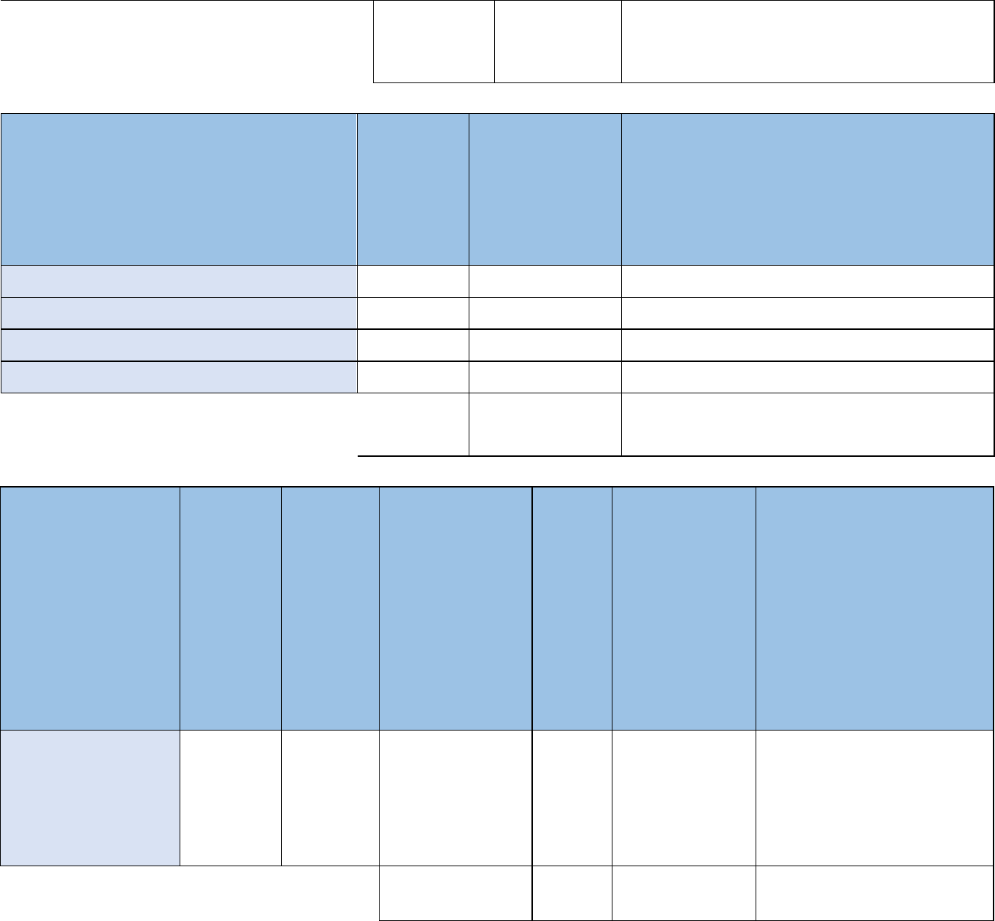

5. SCHEDULE, RESOURCES, RISKS

1/2 Project work schedule

Project work schedule | Appendix "Project work schedule" according to the
Project work schedule | template

Stage no ... (stage number is generated automatically, stages may overlap in time)

Stage name | Max. 200 characters
Stage implementation period | yyyy/mm – yyyy/mm
Description of planned R&D work within the stage | Max. 4000 characters
Member(s) of the research group/partners implementing the | Max. 2000 characters
stage | Max. 2000 characters
Page 9 from 18


Milestone name (multiplied section)

Description of how the milestone parameters are verified Description of the impact of not achieving the milestone on the implementation of the Project
Max. 200 characters

Max. 500 characters

Max. 500 characters

+ option to add another stage (table as in 1/2)

2/2 Potential for Project implementation

Research group members

Technical resources available and obtainable within the project
Key project risks, including scientific or technological risks, along with measures to mitigate them

Max. 2000 characters

Max. 2000 characters

Max. 2000 characters

6. PROJECT BUDGET

1/5 Project timeframe

Project duration Date copied automatically from the project information section

2/5 Settlement periods

12-month settlement The system automatically divides the project duration period based on the

periods start and end dates into 12-month periods

3/5 Budget category amounts planned for subsequent settlement periods

Name

Task 1. Conducting R&D work

1.1a Remuneration of R&D personnel including remuneration of persons acting as brokers

1. year 2. year 3. year N+1


… … … …


Position name (planned for persons employed under an employment contract)

Planned (gross

gross) monthly

employment cost

Planned full-time 0-1 equivalent

Duration of

employment (in

months)

Estimated total

cost of the

contract for the

entire project

implementation

period

JUSTIFICATION | Max. 800 characters
 | + add another position
 | Page 10 from 18

Position name (planned for persons employed on the basis of a civil law contract, i.e. a contract of mandate for R&D work – if planned (in accordance with section

3.2.1(i) of the Guidelines)) (First and last name – if known at the stage of the submitting the Funding Application)

JUSTIFICATION

1.1b Stipends Doctoral students

JUSTIFICATION

Students

JUSTIFICATION

1.2 Development of R&D staff (domestic and international training, summer schools)

JUSTIFICATION

1.3 Other direct costs

JUSTIFICATION

Planned (gross
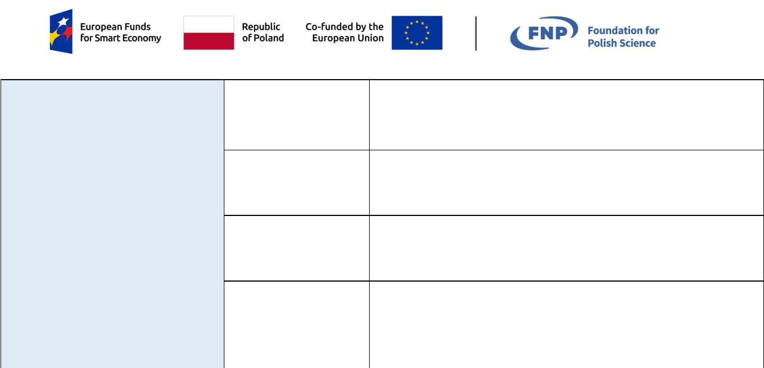

gross) monthly

employment cost

Planned time 0-1

commitment as a

full-time equivalent

Duration of

employment (in

months)

Estimated total cost

of the contract for

the entire duration of

the Project

Max. 800 characters

+ add another position

… … … …


Planned monthly

stipend amount

Number of

person-months

Estimated total

cost for the entire

project

implementation

period

Max. 800 characters

- add another position Planned monthly

stipend amount

Number of

person-months Estimated total cost for the entire project implementation period

Max. 800 characters

+ add another position


… … … …

Max. 1000 characters

… … … …

Max. 2000 characters

Page 11 from 18

Task 2. Equipment

2.1 Purchase of scientific and research equipment

JUSTIFICATION

Task 3. Subcontracting

3.1 Subcontracting

JUSTIFICATION

Task 4. Project promotion

4.1 Project promotion

JUSTIFICATION

… … … …


Max. 2000 characters

… … … …

Max. 2000 characters

… … … …

Max. 2000 characters

Task 5. Indirect costs of the

Project

5.1 Indirect costs of the | … | … | … | …
Project
JUSTIFICATION |  | Max. 2000 characters
4/5 Total costs
Total of all costs within 12-month periods
Total | The system calculates the values automatically
Funding | The system calculates the values automatically
Eligible | The system calculates the values automatically
Total of all costs in the budget
Total | The system calculates the values automatically
Funding | The system calculates the values automatically
Eligible | The system calculates the values automatically
5/5 Material and financial schedule
Material and financial | Appendix entitled "Material and financial schedule" in Excel spreadsheet
schedule | and .pdf format
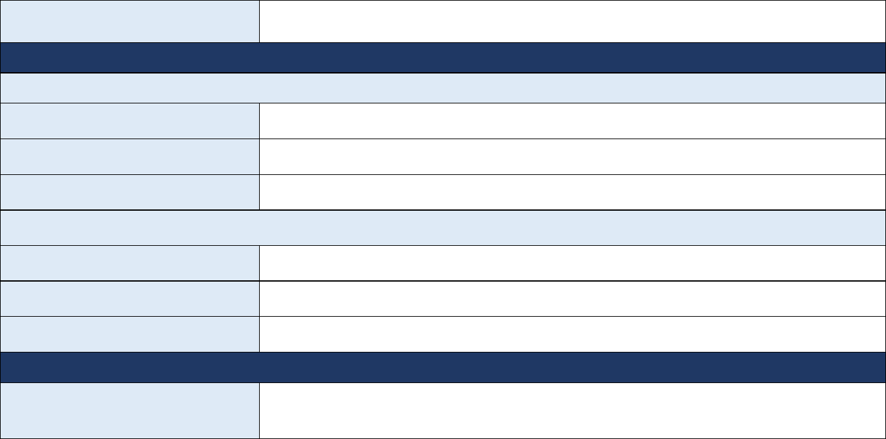

- PROJECT COMPLIANCE WITH EU HORIZONTAL POLICIES, ENVIRONMENTAL INDICATORS

Page 12 from 18

1/5 Compliance with horizontal principles of equal opportunities and non-discrimination


Justification of the Project's compliance with the principle of equal opportunities and non-discrimination

Products/services in the Project (multiplied section)

Name of product/service

Impact

Justification


Justification of the project's compliance with the principle of equality between women and men

Max. 4000 characters


Max. 100 characters

Positive/neutral (select one)

Max. 500 characters


Max. 3000 characters

2/5 Project compliance with the Charter of Fundamental Rights (CFR)

Justification Max. 4000 characters

3/5 Project compliance with the Convention on the Rights of Persons with Disabilities

Justification Max. 4000 characters

4/5 Compliance with the principle of sustainable development


Compliance of the project with environmental protection regulations, with reference to the relevant legal acts


Description of how the project will be implemented in accordance with the 6R principles or in accordance with its positive impact on other environmental aspects (not covered by the 6R principles); at least 2 environmental indicators should be indicated in the table

Max. 2000 characters


Max. 4000 characters

Page 13 from 18

5/5 Environmental indicators


Description

of the

methodology

for

calculating

the indicator

Environmental

indicator

Indicator 1 – name of the indicator


Type of indicator

Dropdown list:

6R principle: refuse

6R principle: reduce

6R principle: reuse

6R principle: recover

6R principle: recycle

6R principle: rethink Environmental aspect other than 6R

 | Target | Unit of | Base | Year of target
Baseline | Target | measu | Base | value
Baseline | value | measu | year | value
 | value | rement | year | achievement


… … … … …


and the

method of

monitoring

and verifying

the

achievement

of the

planned

indicator

values

Max. 500

characters

Indicator 2 – name of the indicator

Dropdown list:

6R principle: refuse

6R principle: reduce

6R principle: reuse

6R principle: recover

6R principle: recycle

6R principle: rethink Environmental aspect other than 6R

… … … … …

Max. 500

characters

+ possibility to add another environmental indicator

8. STATEMENTS

1/3 Statement by the Principal Investigator of the Project

Statement by the Principal Investigator of the | Appendix „Statement by the Principal Investigator of the
Project | Project” based on the template

2/3 Mandatory statements by the Applicant


- I declare that I am aware of the criminal liability (under Articles 270, 271, 273 of the Criminal Code concerning offences against the authenticity of documents and Article 297 of the Criminal Code) for submitting forged, altered, untrue or unreliable documents and for making unreliable written statements regarding circumstances of significant importance for obtaining support.

Page 14 from 18

Yes (only option to be selected)


- I declare that I have read the Regulations for Project selection, including its annexes, and accept their provisions.

- I undertake to make the project implementation site available for the purposes of assessment prior to the signing of the project grant agreement, carried out by the Managing Authority, the Intermediate Body or another authorised institution or organisational unit.

- I declare that the institution I represent has the consent of all persons whose personal data I provide in the Application to process this data and entrust it to the Intermediate Body for the purpose of conducting the project selection procedure.
- I declare that the institution I represent has the originals of the documents whose scans have been attached to the application.
- I undertake to participate in surveys, interviews and to provide information for the purposes of evaluation (assessment) carried out by the Managing Authority, the Intermediate Body or another authorised institution or organisational unit or entity carrying out the evaluation.

Yes (only option to be selected)

Yes (only option to be selected)

Yes (only option to be selected)

Yes (only option to be selected)


Yes (only option to be selected)

3/3 Optional statements by the Applicant (if applicable)


I declare that if the project is selected for funding, the Applicant will apply for the necessary permits for its implementation and will refrain from commencing research work until the necessary authorisations have been obtained.

Statement of application for ethical committee approval, required under the provisions on animal experimentation.

Declaration of application for consent required under nature conservation regulations.

Declaration of application for consent required under the provisions on genetically modified organisms.

Declaration of application for consent or authorisation required by relevant regulations for projects related to clinical trials.

Yes/Not applicable (select one)

Yes/Not applicable (select one)

Yes/Not applicable (select one)

Yes/Not applicable (select one)

Information clause

Data controller

The controller of the personal data of all persons involved in the implementation of the First Team Project (on behalf of the Applicants, Beneficiaries, external entities, including those indicated in the application for Project funding in the competition: contact persons for the evaluation of the Project on behalf of the Applicant, on behalf of the Economic Partner, the Principal Investigator), as well as persons authorised to maintain ongoing contact within the framework of the implementation of the Funding Agreement, processed for the purpose of these persons' participation in the process of applying for support and subsequent possible implementation of the First Team Project, is the Foundation for Polish Science with its registered office in Warsaw, at ul. Ignacego Krasickiego 20/22, 02-611 Warsaw, entered in the register of associations, other social and professional organisations, foundations and independent public healthcare institutions, kept by the District Court for the Capital City of Warsaw in Warsaw, 13th Commercial Division of the National Court Register, under KRS number 0000109744, NIP 5260311952, REGON 012001533). The data controller processes all personal data specified in the Application for Funding of the Project in the competition and other personal data indicated in the competition and project documentation.

Page 15 from 18

Data Protection Officer

The controller has appointed a Data Protection Officer (DPO). You can contact the DPO in all matters relating to the processing of personal data at the following e-mail address: iodo@fnp.org.pl or at the address of the Administrator's registered office.

Purpose, legal basis and duration of processing

Personal data is processed for the purpose of implementing a project financed by the European Union on the basis of the provisions of the Act of 28 April 2022 on the Principles of Implementing Tasks Financed from European Funds in the 2021-2027 Financial Perspective, and in particular:

  - evaluation and selection of the Funding Application. If funding is granted:
conclusion of a contract for the implementation and financing of the Project, supervision of the Project implementation,

its evaluation, control, audit,

assessment of information and promotional activities,

acceptance of the Project, its evaluation and financial settlement,

and, where applicable, the determination, investigation or defence of claims.

Personal data has been obtained from the Applicant who completed the Funding Application in the FNP system, or personal data may come from publicly available registers.

The legal basis for the processing of personal data by the Controller is the fulfilment of legal obligations and the performance of tasks carried out in the public interest or in the exercise of official authority vested in the controller. The provision of personal data is a statutory requirement and failure to provide such data may result in a negative assessment of the application or failure to conclude a grant agreement.

Personal data will be processed in accordance with the provisions on national archival resources and archives until the completion of all tasks related to the implementation and settlement of FENG 2021-2027, subject to provisions that may provide for a longer period of control, and, in addition, the provisions on state aid and de minimis aid, as well as the provisions on goods and services tax.

Recipients of personal data

Personal data may be transferred to the following categories of data recipients: public authorities and entities performing public tasks or acting on behalf of public authorities, in particular: the European Funds Spokesperson, experts, the Audit Authority, European Union (EU) institutions or entities entrusted by the EU with tasks related to the implementation of FENG 2021-2027, to the extent and for the purposes resulting from legal provisions, entities providing services necessary for the performance of FNP tasks, including IT partners, entities providing technical or organisational support (such entities process data on the basis of a contract with the Controller and only in accordance with its instructions). In the case of transfer of personal data to experts or reviewers outside the EU, personal data will be transferred to a third country in compliance with

Page 16 from 18

the requirements established by personal data protection regulations and appropriate or relevant safeguards.

Rights of data subjects

At every stage of data processing by the FNP, you have the right to:

- access your data, including obtaining information about the scope of data processed by us and obtaining a copy of such data;

- modify and correct your data, unless there are other legal contraindications to limiting the scope of its processing;

- completely delete your data ("right to be forgotten"), unless there are other legal contraindications;

- not be subject to automated decisions based on profiling;

- object to the processing of personal data, unless there are other legal contraindications;

- restriction of processing, unless there are other legal contraindications;

- to transfer data to another Data Controller if the data is processed in connection with consent given or a contract concluded;

- lodge a complaint with the President of the Data Protection Authority for improper data processing;

- withdraw consent at any time without affecting the lawfulness of the processing carried out on the basis of consent prior to its withdrawal (if the processing is based on consent).

Detailed information on how to exercise your rights can be found on the FNP website (www.fnp.org.pl), in the Personal Data Protection tab (https://www.fnp.org.pl/ochrona-danych-osobowych/). By proceeding to edit the application, I declare that the persons whose data is included in this form have been informed of this fact by providing them with information on personal data protection, as indicated in the above information clause. I declare that, at the request of the Intermediate Body, I will provide confirmation (in writing or in the form of a document) that these persons have read the above information clause.

  - VERIFICATION AND SUBMISSION OF THE APPLICATION

1/3 Verification and closure of the application


The system automatically verifies the application in terms of the required fields and attachments. Any errors or omissions are displayed with an indication of the section where the correct data should be entered. Correct verification is associated with the activation of the "Finish editing data" button. After using the button, it will not be possible to make further changes to the application.

2/3 Generating and downloading the application


Button allowing you to generate the application and download it as a .pdf file
Generate application
The downloaded application must be signed with an electronic
signature.

3/3 Attaching the signed application


To submit the application correctly, attach the signed, previously generated .pdf application and then use the "Submit the application" button. The system will inform you that the application has been submitted correctly and will send information to the email addresses indicated in the application to the contact person on behalf of the Applicant and to the Principal Investigator of the Project.

Page 17 from 18

Page 18 from 18

